**Module -13 Assignment**

**Q1.) Problem Statement: Create an image gallery using a CSS grid.**

**Q2.) Problem Statement: Write code to arrange containers with texts A, B, C, and D as shown in the below image.**

**Q3.) Problem Statement: Explain the use of grid-auto-row and grid-auto-column using code examples.**

**Q4.) Problem Statement: Write CSS to show numbers as shown in the figure, without altering the below html code.**

**<div class="container">**

**<div class="box box1">1</div>**

**<div class="box box2">2</div>**

**<div class="box box3">3</div>**

**<div class="box box4">4</div>**

**<div class="box box5">5</div>**

**<div class="box box6">6</div>**

**<div class="box box7">7</div>**

**<div class="box box8">8</div>**

**</div>**

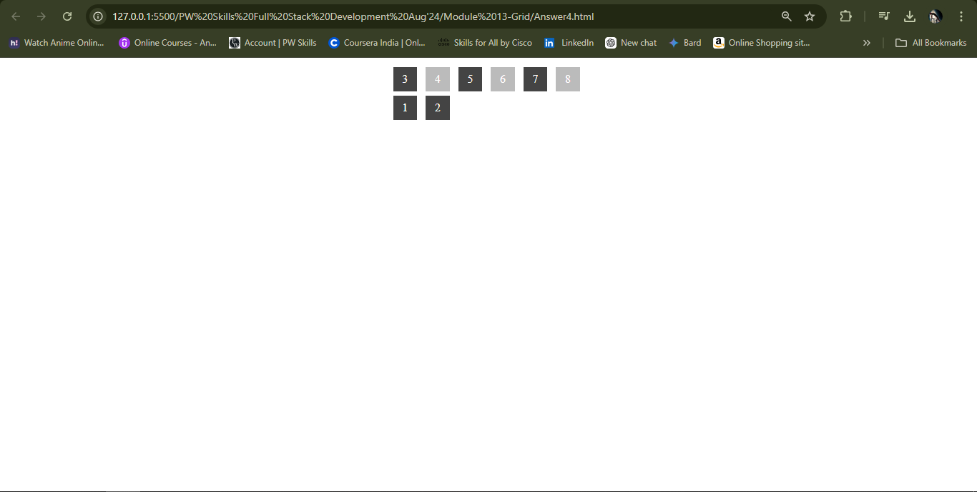

**Q5.) Problem Statement: Explain the difference between justify-items and justify-self using code examples.**